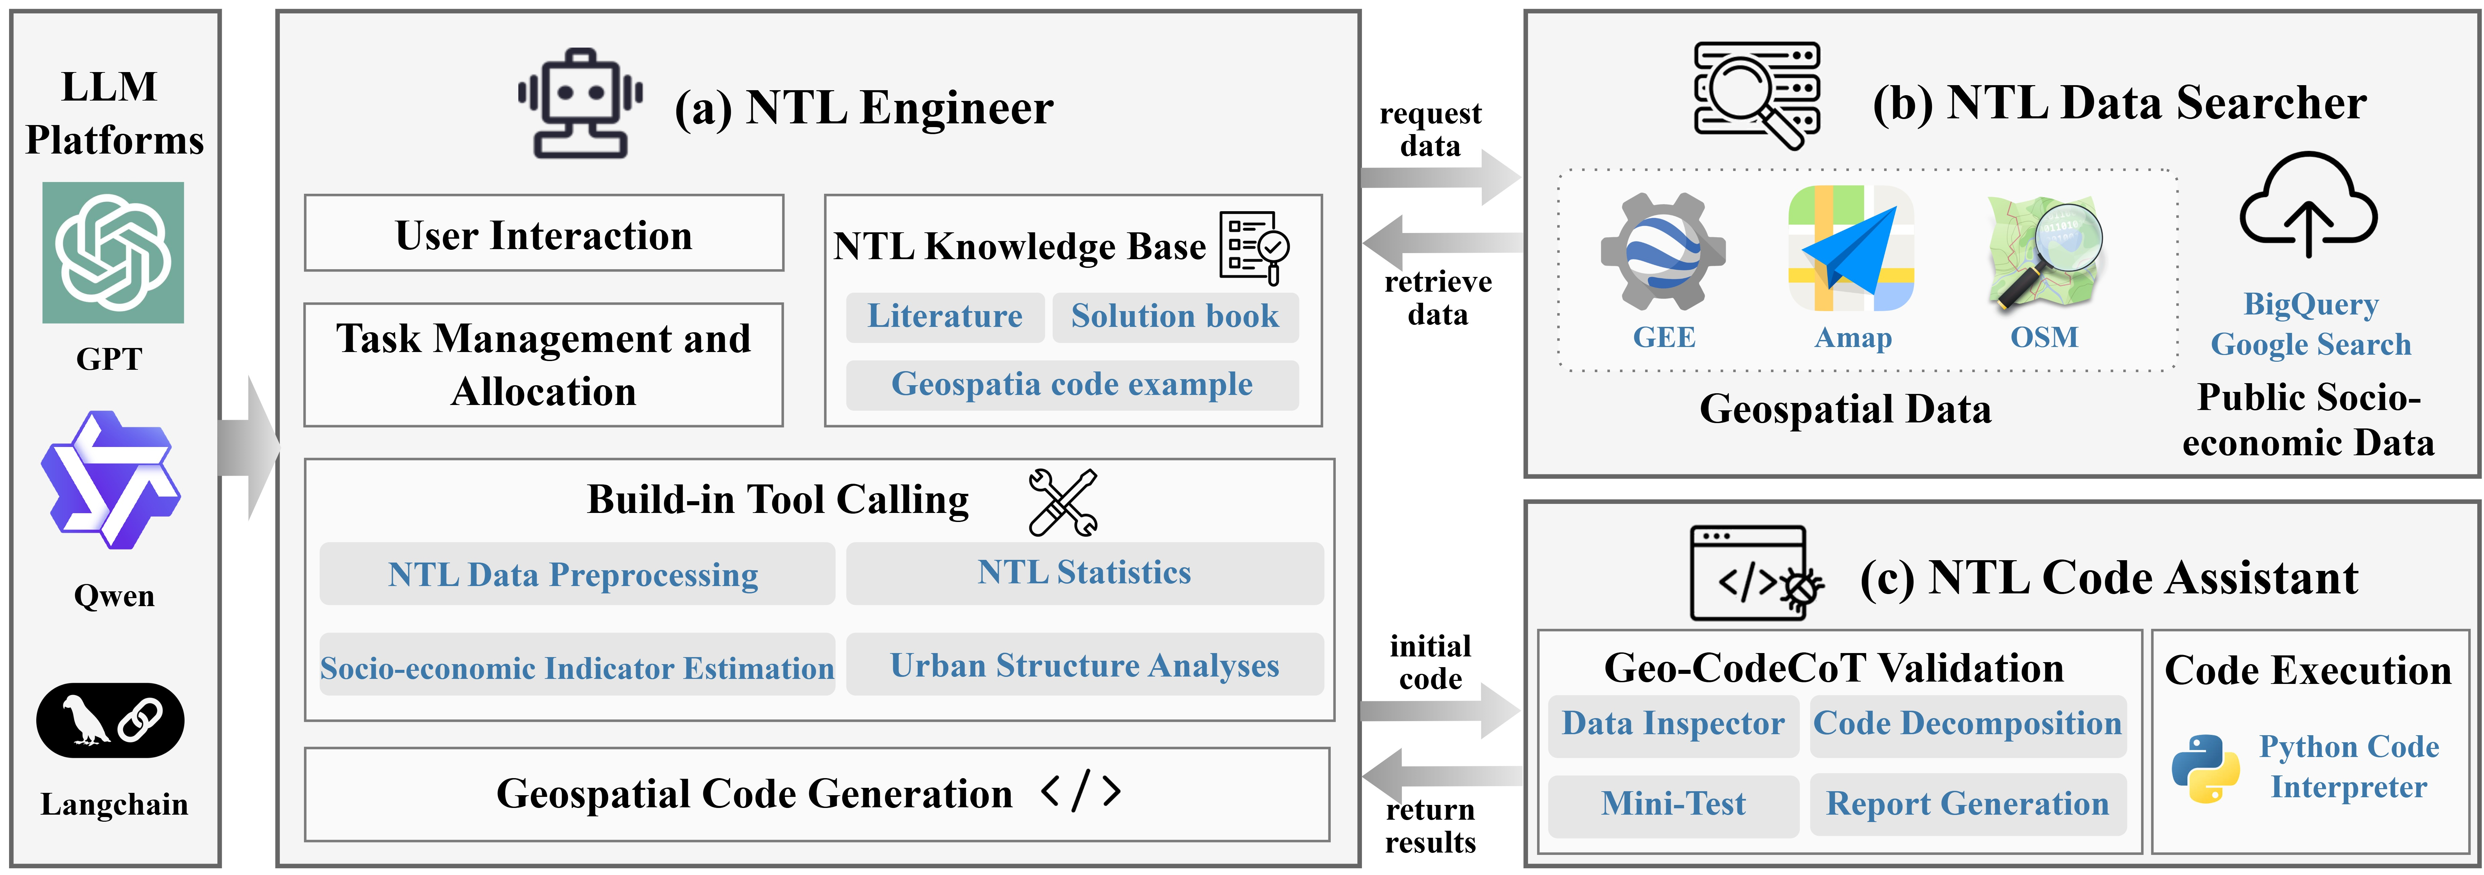

**Fig. 1.** The architecture of the NTL Engineer, the NTL Data Searcher, and the NTL Code Assistant in the NTL-GPT multi-agent framework.



**Fig. 2.** End-to-end NTL analysis workflow with NTL-GPT.



**Fig. 3.** Standardized data retrieval outputs from the NTL Data Searcher, including geospatial and socio-economic data with metadata for downstream processing.



**Fig. 4.** Workflow of the Geo-CodeCoT framework, comprising data inspection, code block decomposition, mini-test execution, and validation reporting for robust geospatial code execution in the NTL Code Assistant.



**Fig. 5.** Data retrieval and preprocessing tasks supported by NTL-GPT.



**Fig. 6.** NTL spatial statistic and querying tasks supported by NTL-GPT.



**Fig. 7.** Workflow of socio-economic indicator modelling using NTL-GPT: regression analysis between annual ANTL and GDP in Shanghai (2013–2022).



**Fig. 8.** Urban light type classification using SDGSAT-1 RGB imagery and RRLI/RBLI indices in Shanghai.



**Fig. 9.** NTL-based disaster monitoring of the 2025 Myanmar earthquake using daily NPP-VIIRS imagery and multi-source event data.



**Fig. 10.** Example of the NTL Code Assistant’s data inspection report, highlighting metadata validation and field mismatch issues with suggested fixes.